# INDIA’S AGRICULTURAL CROP PRODUCTION ANALYSIS(1997-2021)

**TEAM MEMBERS:**

1. **HEMAVATHI.J**
2. **GAYATHRI.R**
3. **KALPANA.M**
4. **KAVIYA.M**

#### PROJECT REPORT

INTRODUCTION:

**Overview:**

* **This report delves into the captivating realm of India's agricultural cultivation, providing a comprehensive visual exploration of key aspects and trends in the agricultural sector. Through the visual representations, readers can gain valuable insights into crop production, seasonal variations, regional distribution, and overall production trends. These visualizations enable intuitive analysis, allowing stakeholders to uncover patterns, identify areas of growth or concern, and make data-driven decisions.**
* **By harnessing the power of Tableau, this report not only presents the data in a visually appealing manner but also provides an interactive experience for readers to explore the intricacies of India's agricultural cultivation. To Extract the Insights from the data and put the data in the form of visualizations, Dashboards and Story we employed Tableau tool.**

**PURPOSE:**

* **Crop production is the basis for providing the livestock industry with feed, and the population with food. Also, crop products are used in many industries as raw materials of plant origin, such as food, textile, pharmaceutical, fuel and others.**

#### PROBLEM DEFINITION AND DESIGN THINKING:

* **Design thinking can be used to identify opportunities for innovation in regenerative farming practices, such as using cover crops to improve soil health or integrating livestock into crop rotations to improve nutrient cycling.**

EMPATHY MAP: 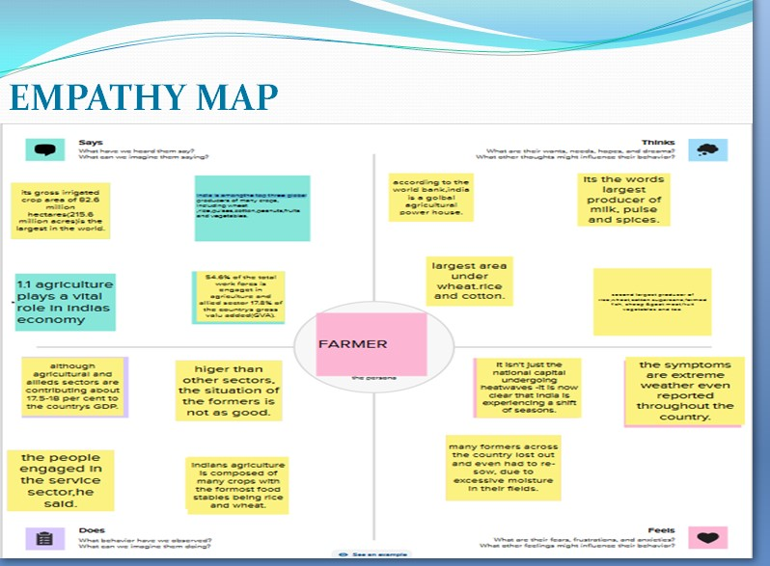

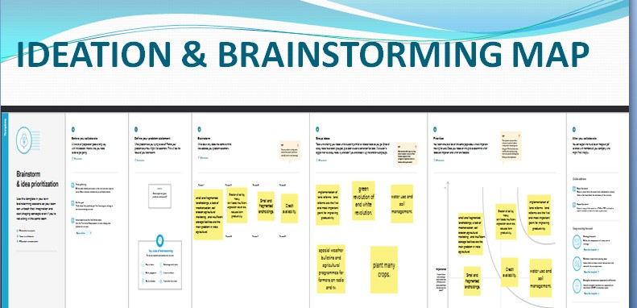

RESULT:

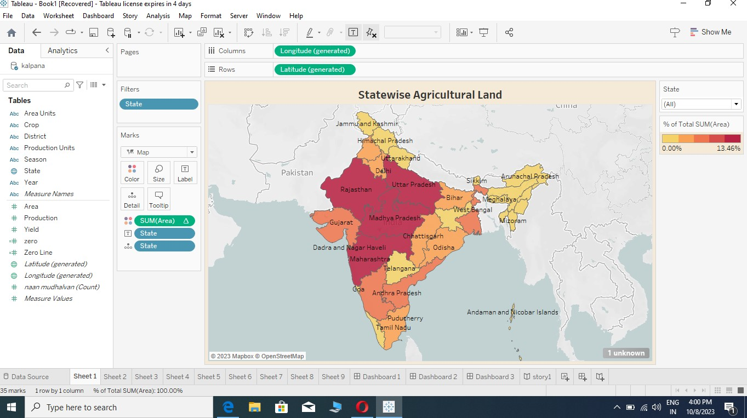

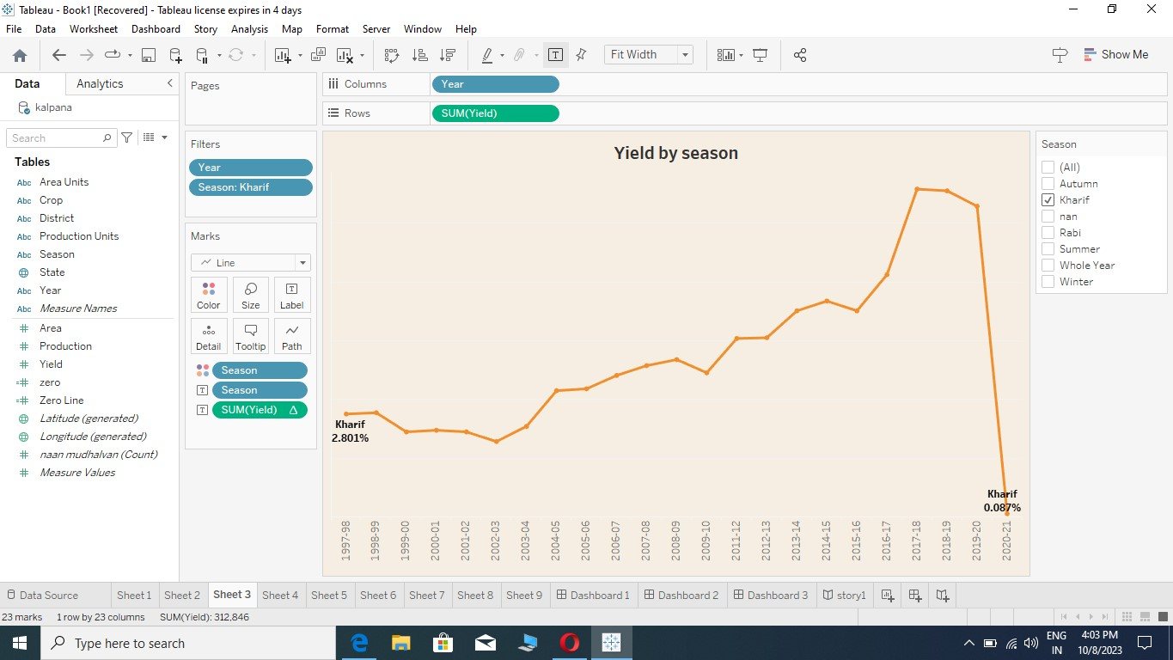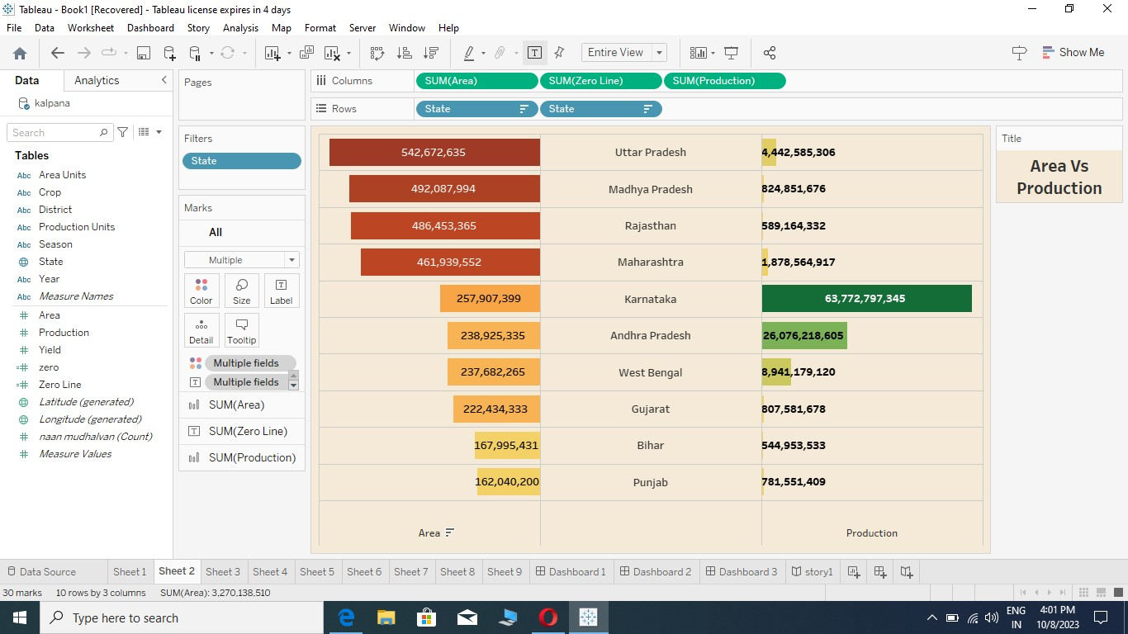

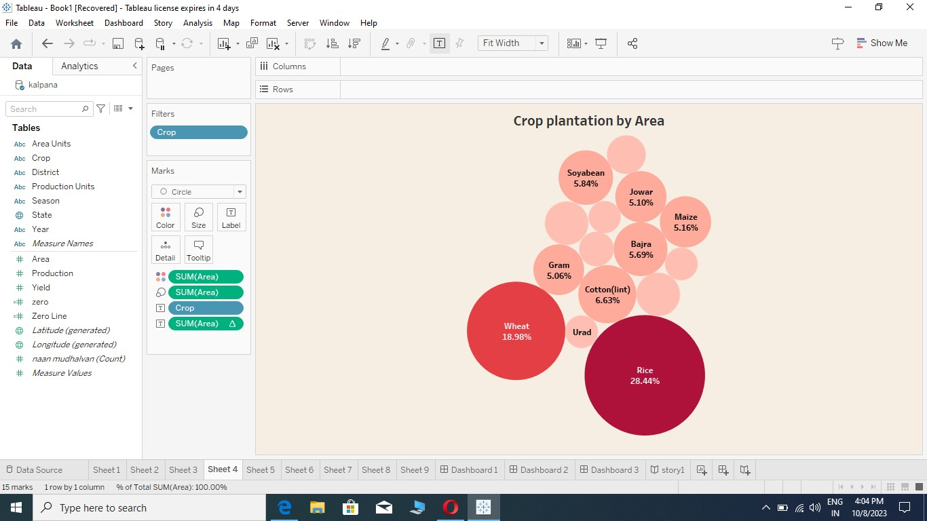

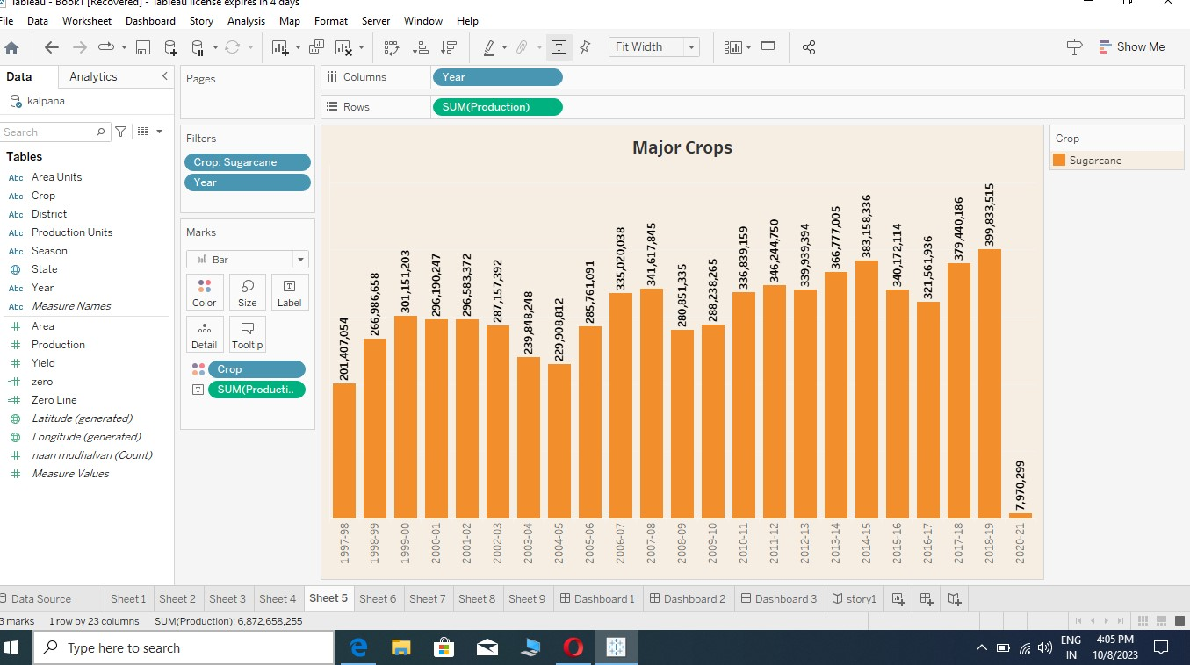

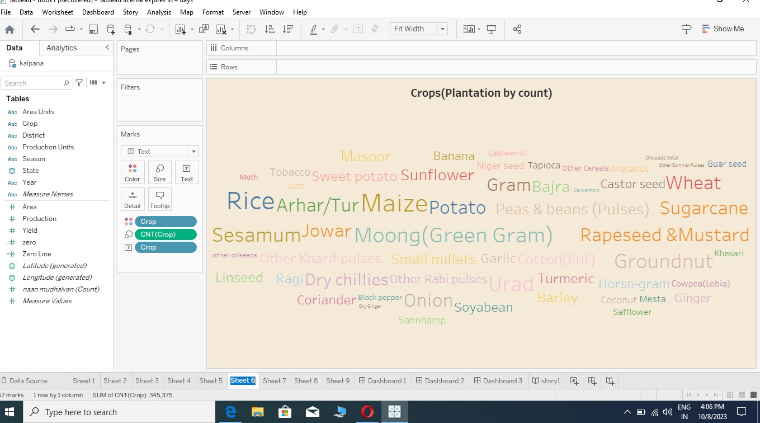

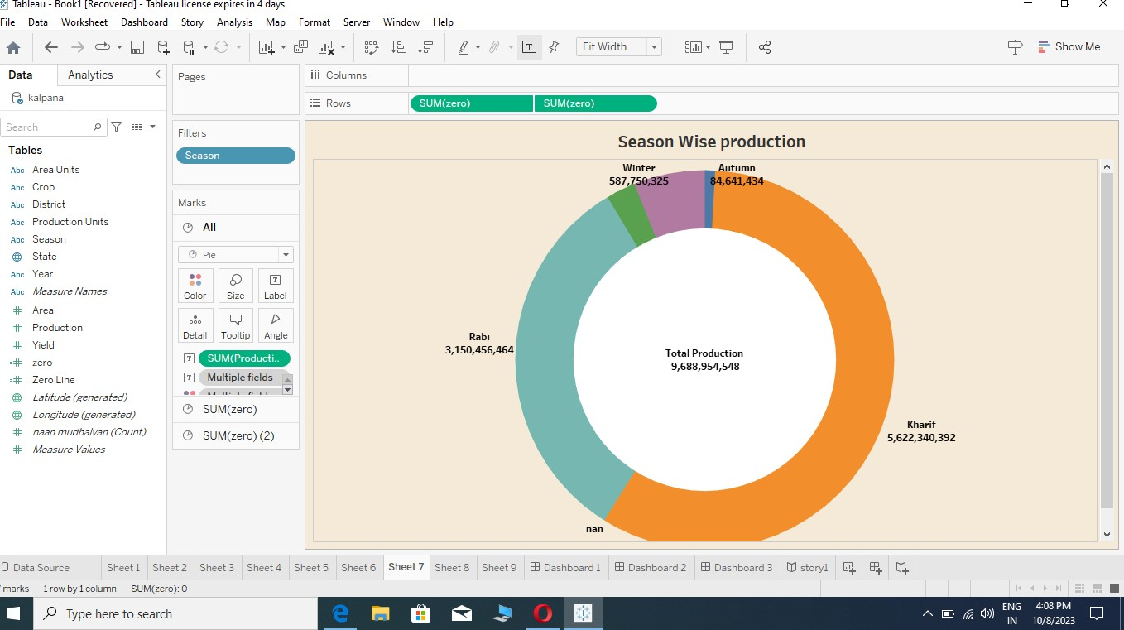



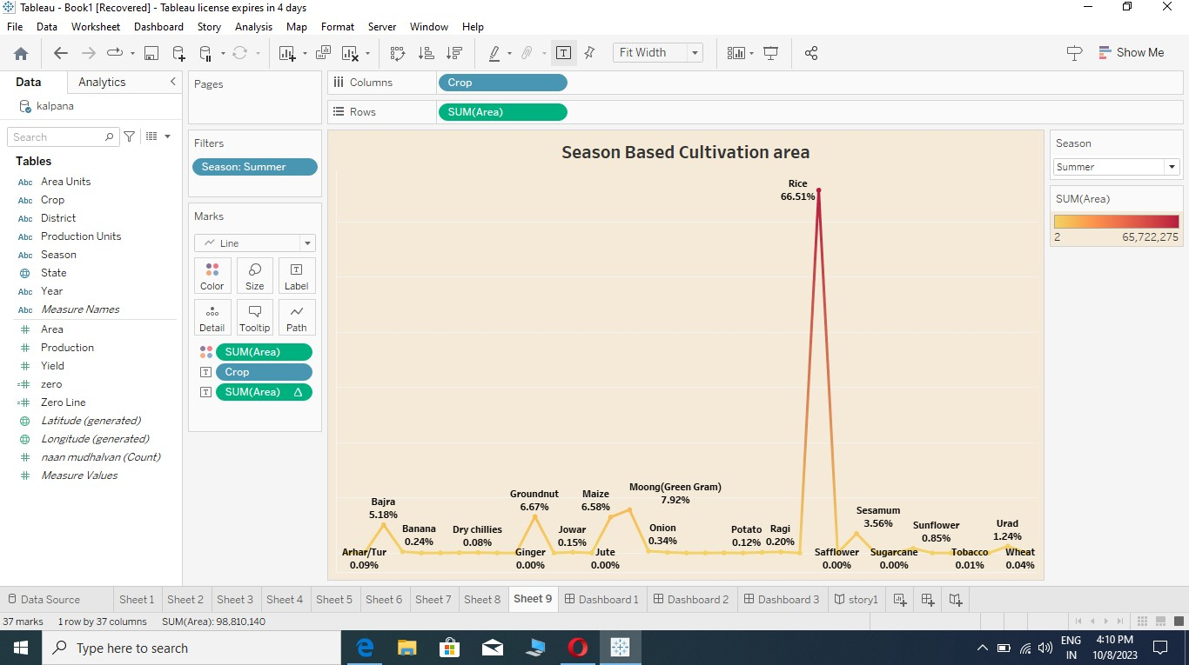

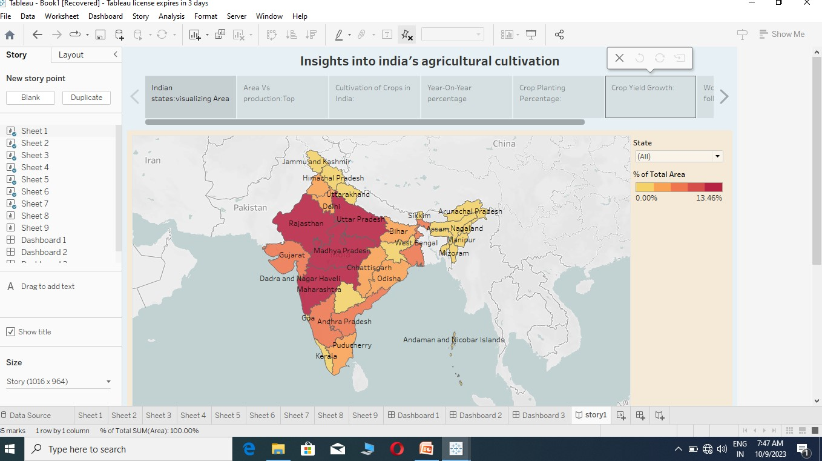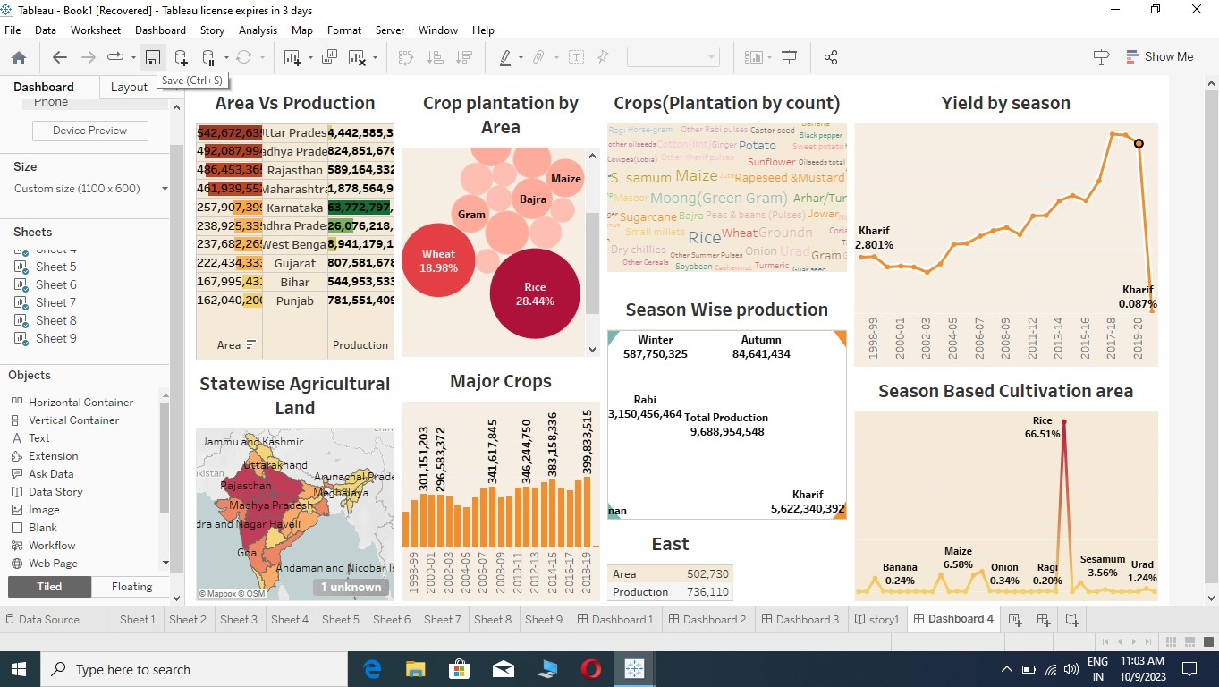

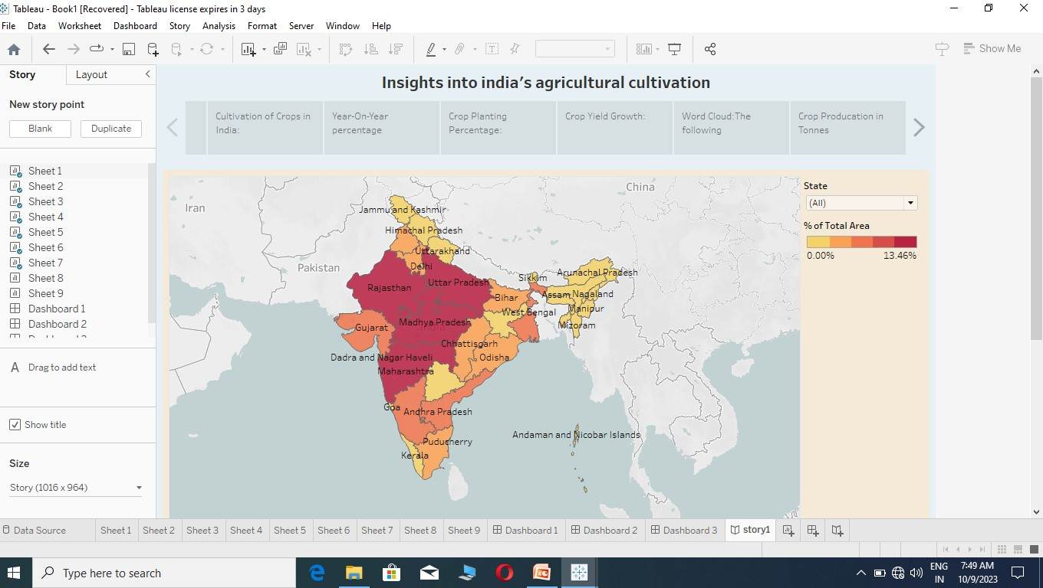

# ADVANTAGE:

* **Agriculture supplies raw materials to various agro-based industries like sugar, jute, cotton textile and vanaspati industries.**
* **Supporting livelihoods through food, habitat, jobs; providing raw materials for food& other products; &building strong economies through trade.**
* **Optimizes resources utilization & output management.**
* **There is over all increase in yield of crops mainly due to maintaining physical- chemical properties of soil. Soil fertility is restored by fixing atmospheric nitrogen, encouraging microbial activity (more organic matter) and protecting soil from erosion, salinity and acidity.**
* **It helps in controlling insects, pests and soil borne diseases. It also controls weeds. E.g. repeated wheat culture (growing) increases wild oats and phallaris infestation. Similarly growing berseem continuously encourages chicory (kasani) infestation, but an alternate cropping of berseem and wheat helps in controlling kasani as well as oats and phallaris.**
* **Prevent or limit periods of peak requirements of irrigation water. Crops requiring high irrigation if followed by light irrigation, this will not affect or deteriorate the soil physical condition.**
* **It facilitates even distribution of labour. Following crop make proper utilization of all resources and inputs. Family and farm labour, power, equipment and machines are well employed thought the year.**
* **Farmers get a better price for his produce due to higher demand in local market. So there is regular flow of income over year.**

# DISADVANTAGE:

* **Erosion of soil by heavy rain, floods, insufficient vegetation cover etc., reduces farm productivity. Inadequate irrigation facilities and poor management of water resources have led to a great decline in agricultural productivity.**
* **Large-scale, conventional farming focuses on intensive single crop production, mechanization, and depends on fossil fuels, pesticides, antibiotics, and synthetic fertilizers.**
* **While this system yields high production levels, it also contributes to climate change, pollutes air and water, and depletes soil fertility.**
* **The biggest drawback would be adapting to the significant shift in the environment because you'd have had to relocate nearer to your farms, which would most likely be in a remote setting.**
* **The present challenges that plague Indian agriculture are limited knowledge and insufficient infrastructure, especially in the rural areas.**

# APPLICATION:

* **Smart alarm for external factors**
* **Disease Diagnosis**
* **Soil fertility and Erosion analysis**
* **Pesticides suggestion**
* **Auto irrigation**
* **Crop quality assessment**
* **Seed quality assessment**

# Conclusion:

* **On overall view, Indi has always been benefited by AGRICULTURE.**
* **Though the future of India is Industrialization, the contribution of agriculture would always prove to be vital for making India a powerful & stable economy in the future.**

# FUTURE SCOPE:

* **There will be more of vertical and urban farming and there will also be efforts in long term to find new areas for production like barren deserts and seawater.**
* **Hydroponic farming, which is a soil-less, water-based farming operation, that may even be done in a tiny space is going to pick up the pace**